,

# IMPLEMENTING E-LIBRARY IN GOVERNMENT SCHOOLS

**A Community Service Project Report**

Submitted to the Faculty of Engineering of

**JAWAHARLAL NEHRU TECHNOLOGICAL UNIVERSITY KAKINADA**

**KAKINADA**

In partial fulfillment of the requirements for the award of the Degree of

**BACHELOR OF TECHNOLOGY**

In

**COMPUTER SCIENCE AND ENGINEERING**

By

**Chilumuru Yamini Naga Sai Prasanna(21481A0549)**

**Badampudi Satya(21481A0513)**

**Bhimireddy Lalitha(21481A0528)**

**Biruda Yagna Priyanka(21481A0531)**

Under the Enviable and Esteemed Guidance of

**Mrs.Dr.N.Rajeswari ,**M.Tech,Ph.D

Professor, Department of CSE



**DEPARTMENT OF COMPUTER SCIENCE AND ENGINEERING**

**SESHADRI RAO GUDLAVALLERU ENGINEERING COLLEGE**

**(An Autonomous Institute with Permanent Affiliation to JNTUK, Kakinada)**

**SESHADRIRAO KNOWLEDGE VILLAGE**

**GUDLAVALLERU – 521356**

**ANDHRA PRADESH**

**2023-24**

**Program Book for**

**Community Service Project**



**Name of the College:** **Seshadri Rao Gudlavalleru Engineering College**

**Registration Number: 21481A0549**

**21481A0513**

**21481A0528**

**21481A0531**

**Period of CSP: From:15-5-2023 To: 16-9-2023**

**Name&Address of Community/Habitation: Angaluru Village,**

**Gudlavalleru Mandal,**

**Krishna District,**

**Andhra Pradesh.**

**Community Service Project Report**

*Submitted in accordance with the requirement for the degree of*

**BACHELOR OF TECHNOLOGY**

In

**COMPUTER SCIENCE AND ENGINEERING**

Name of the College**:** **Seshadri Rao Gudlavalleru Engineering College**

Department**: COMPUTER SCIENCE AND ENGINEERING**

Name of the Faculty Guide: **Mrs.Dr.N.Rajeswari ,** M.Tech,Ph.D

# Duration of the CSP:From: 15-5-2023 To: 16-9-2023

Name of the Student:  **Chilumuru Yamini Naga Sai Prasanna**

**Badampudi Satya**

**Bhimireddy Lalitha**

**Biruda Yagna Priyanka**

Programme of Study Year of Study: B.Tech IIIrd Year

Register Number: **21481A0549**

**21481A0513**

**21481A0528**

**21481A0531**

Date of Submission:**20-12-2023**

# Student’s Declaration

We **Badampudi Satya(21481A0513), Bhimireddy Lalitha(21481A0528), Biruda yagna Priyanka(21481A0531),Chilumuru YaminiNagaSaiPrasanna(21481A0549)** the students of **BACHELOR OF TECHNOLOGY,** of the **COMPUTER SCIENCE AND ENGINEERING** Department ofSeshadri Rao Gudlavalleru Engineering Collegedo hereby declare that we have completed the mandatory community service From: 15-5-2023 To: 16-9-2023 in Angaluru, under the Faculty Guide ship of **Mrs.Dr.N.Rajeswari** M.Tech,Ph.D,Professor, Department of Computer Science And Engineering,Seshadri Rao Gudlavalleru Engineering college,Gudlavalleru.

(Signature and Date)

# Endorsements

Faculty Guide

Master of Trainer(S):

Head of the Department

Principal

**Certificate from Official of the Community**

This is to certify that Chilumuru Yamini Naga Sai Prasanna (21481A0549),Badampudi Satya(21481A0513),Bhimireddy Lalitha(21481A0528), Biruda Yagna Priyanka(21481A0531) of Seshadri Rao Gudlavalleru Engineering College underwent community service in Angaluru.

From: 15-5-2023 To: 16-9-2023

The overall performance of the Community Service Volunteer during his/her

community service is found to be Satisfactory.

Authorized Signatory with Date and Seal

**ACKNOWLEDGEMENTS**

We wish to express our gratitude to those who extended their valuable cooperation and contribution towards successful completion of this project. We would like to thank our project guide **Mrs.Dr.N.Rajeswari** M.Tech,Ph.D,Professor,Department of Computer Science And Engineering for her valuable time and continued assistance for the completion of the project. Without their support and guidance,it would not have been possible for this project to have materialized and taken a concrete shape.

We would like to extend our sincere gratitude to **Dr. M.Babu Rao**, Head of the

Department, and project coordinator **Dr.SK.Salma Begum** for facilitating this project and

providing guidance throughout the duration of the project.

We express our gratitude to our principal, **Dr.B.Karuna Kumar** for his encouragement and the facilities provided throughout the course of the project.

We wish to express our deep sense of gratitude to our institution, Seshadri Rao Gudlavalleru Engineering College,Gudlavalleru, for providing us the opportunity to carry out this Community Service project(CSP).

We wish to express gratitude to all our friends who have helped us in various stages and

provided valuable suggestions throughout the project. Thanks to all the communit members

who assisted in the successful completion of the project. We also grateful to the Angaluru

Community members and Officials for granting permission to conduct our project in a well-

organized manner.

We would also like to express our thanks to Teaching and Non-Teaching staff of the

Computer Science And Engineering Department who helped us directly or indirectly in

completion of our project.

**Chilumuru Yamini Naga Sai Prasanna(21481A0549)**

**Badampudi Satya(21481A0513)**

**Bhimireddy Lalitha(21481A0528)**

**Biruda Yagna Priyanka(21481A0531)**

### CHAPTER 1: EXECUTIVE SUMMARY

### 

The community service project is about to bring awareness in government schools about Importance of Library in schools and about the books they have to study in their schooling era.Library is one of the most essential needs for the students nowadays. Apart from the learning that the students get from the classroom teaching Libraries will act as an extra source of information to improve one’s knowledge. The study was carried out in Angaluru,Krishna District . The study aimed to implement the E-library system in the government schools and Anganwadis.

So, preparing a E-Library system platform involves designing and structuring a database to efficiently store and manage various StudyBooks,TextBooks,Magazines StudyBooks,Magazines,Textbooks,Journals,Autobiographies of Great Personalities. The E-Library system platform design aims to streamline administrative tasks, enhance knowledge and facilitate the students in getting the best of the information about any kind of topics.

**Learning Objectives:**

* To raise awareness of E-Library in Government schools and Anganwadis
* To increase Access to Educational Resources
* To Enhance the awareness of Digital Literacy in Village schools
* To explore the applications of artificial intelligence in E-library,and it is cost-effective To acquire knowledge and improve how to be communicate the importancce of E-library to villagers.

**Learning Outcomes:**

* The communicative skills have been developed.
* I can identify the problem as engineer problem.
* I can give the solution for the problem.
* I am willing to be active in any social activities.
* I know how to give awareness to people.
* I can implement the prevention steps and future steps, which helps to the community and I gain the knowledge and able to do solutions through various ways.

**CHAPTER 2: OVERVIEW OF THE COMMUNITY**

**The community:**

The community selected for our Community service project is Angaluru. Angaluru is a Village in Gudlavalleru Mandal in Krishna District of Andhra Pradesh State,India.It belongs to Andhra region.It is located 30 KM towards from District head quarters krishna.4.5 KM from Gudlavalleru. Angaluru pin-code is 521330 and postal Head office is Angaluru. The population is about 2097 of total in which 1081 of males and 1016 of female and 212 Children aged (0-6) years. The average literacy rate stands at 64.99% with 1225 literates. significantly lower literacy rate than the west gudivada average of 67.4%. The Total area of Angaluru is 1266 hectares.The non agricultural area in this locality is 547 hectares.The canals are covered with 0 hectares. Frequent transportation facility is available to Angaluru.

Location: -

Angaluru : latitude : 16.226538 longitude :79.778495

**Socio-economic conditions of the communities: -**

The community is having 4 government primary schools for education. The people in the community depends on multiple skills in the village and earn as sufficient. The poverty conditions of the community is well and 55% are above poverty line. The people below poverty line are high and obtaining every scheme, ration shops. Moreover, the people in the community is good at poverty as lands, employment. The people are getting a sufficient income which can satisfy their livelihood. also, students who are pursuing higher degrees and working in other countries. The community people are also various types of occupation like farming in high, construction, Doctors, Teachers, and well settled in other sectors which able to maintain their family happily.

### 

### CHAPTER 3: COMMUNITY SERVICE PART

**The activities done during the community service project are as follows: -**

Firstly, we have taken the acceptance letter from our department and discussed about various topic with allotted guide. She helped us in the taking of the topic and thought the various things regarding the topic. Then we moved to the community and taken permission letter from the Grama sarpanch. The data has been collected from the Grama sarpanch of village population. So, we started our project initially by observing the infrastructure of the Government schools, evaluating the quality of classrooms, Teaching methadologies,playground facilities,Midday meal program,textbooks etc.

Educational workshops are a key components.Covering Topics ranging from health and hygiene to essential career guidance.Simultaneously we focused on enhancing the school infrastructure by observing painting classrooms,repairing and beautifying the overall premises.During our immersive Community Service project at the government schools.Our team spent several days engaging with the students in meaningful way.

The interaction began with Education sessions where we shared insites of various problems that are actually faced by normal students.These sessions sparked lively discusssions allow us to connect with students on a personal level.

Our team discussed with the students deeply about the main problems that are actually faced by the normal students during school hours.Students raised the problem on not having facility of library in their schools.Undertaking a Community Service Project to establish a E-library in the local government school our team embarked on a transformative journey of interactions with the students.

**ACTIVITY LOG FOR THE FIRST WEEK**

|  |  |  |  |
| --- | --- | --- | --- |
| **DAY**  **& DATE** | **BRIEF DESCRIPTION OF THE DAILY ACTIVITY** | **LEARNING OUTCOME** | **Person In-charge Signature** |
| **Day –1** |  |  |  |
| **Day - 2** |  |  |  |
| **Day –3** |  |  |  |
| **Day –4** |  |  |  |
| **Day –5** |  |  |  |
| **Day –6** |  |  |  |

**WEEKLY REPORT**

**WEEK – 1 (From Dt………..….. to Dt… )**

|  |
| --- |
| **Objective of the Activity Done:** |
| **Detailed Report:** |
|  |
|  |
|  |
|  |
|  |
|  |
|  |
|  |
|  |
|  |
|  |
|  |
|  |
|  |
|  |
|  |
|  |
|  |

**ACTIVITY LOG FOR THE SECOND WEEK**

|  |  |  |  |
| --- | --- | --- | --- |
| **DAY**  **& DATE** | **BRIEF DESCRIPTION OF THE DAILY ACTIVITY** | **LEARNING OUTCOME** | **Person In-charge Signature** |
| **Day –1** |  |  |  |
| **Day - 2** |  |  |  |
| **Day –3** |  |  |  |
| **Day –4** |  |  |  |
| **Day –5** |  |  |  |
| **Day –6** |  |  |  |

**WEEKLY REPORT**

**WEEK – 2 (From Dt………..….. to Dt… )**

|  |
| --- |
| **Objective of the Activity Done:** |
| **Detailed Report:** |
|  |
|  |
|  |
|  |
|  |
|  |
|  |
|  |
|  |
|  |
|  |
|  |
|  |
|  |
|  |
|  |
|  |
|  |

**ACTIVITY LOG FOR THE THIRD WEEK**

|  |  |  |  |
| --- | --- | --- | --- |
| **DAY**  **& DATE** | **BRIEF DESCRIPTION OF THE DAILY ACTIVITY** | **LEARNING OUTCOME** | **Person In-charge Signature** |
| **Day –1** |  |  |  |
| **Day - 2** |  |  |  |
| **Day –3** |  |  |  |
| **Day –4** |  |  |  |
| **Day –5** |  |  |  |
| **Day –6** |  |  |  |

**WEEKLY REPORT**

**WEEK – 3 (From Dt………..….. to Dt… )**

|  |
| --- |
| **Objective of the Activity Done:** |
| **Detailed Report:** |
|  |
|  |
|  |
|  |
|  |
|  |
|  |
|  |
|  |
|  |
|  |
|  |
|  |
|  |
|  |
|  |
|  |
|  |

**ACTIVITY LOG FOR THE FOURTH WEEK**

|  |  |  |  |
| --- | --- | --- | --- |
| **DAY**  **& DATE** | **BRIEF DESCRIPTION OF THE DAILY ACTIVITY** | **LEARNING OUTCOME** | **Person In-charge Signature** |
| **Day –1** |  |  |  |
| **Day - 2** |  |  |  |
| **Day –3** |  |  |  |
| **Day –4** |  |  |  |
| **Day –5** |  |  |  |
| **Day –6** |  |  |  |

**WEEKLY REPORT**

**WEEK – 4 (From Dt………..….. to Dt… )**

|  |
| --- |
| **Objective of the Activity Done:** |
| **Detailed Report:** |
|  |
|  |
|  |
|  |
|  |
|  |
|  |
|  |
|  |
|  |
|  |
|  |
|  |
|  |
|  |
|  |
|  |
|  |

**ACTIVITY LOG FOR THE FIFTH WEEK**

|  |  |  |  |
| --- | --- | --- | --- |
| **DAY**  **& DATE** | **BRIEF DESCRIPTION OF THE DAILY ACTIVITY** | **LEARNING OUTCOME** | **Person In-charge Signature** |
| **Day –1** |  |  |  |
| **Day - 2** |  |  |  |
| **Day –3** |  |  |  |
| **Day –4** |  |  |  |
| **Day –5** |  |  |  |
| **Day –6** |  |  |  |

**WEEKLY REPORT**

**WEEK – 5 (From Dt………..….. to Dt… )**

|  |
| --- |
| **Objective of the Activity Done:** |
| **Detailed Report:** |
|  |
|  |
|  |
|  |
|  |
|  |
|  |
|  |
|  |
|  |
|  |
|  |
|  |
|  |
|  |
|  |
|  |
|  |

**ACTIVITY LOG FOR THE SIXTH WEEK**

|  |  |  |  |
| --- | --- | --- | --- |
| **DAY**  **& DATE** | **BRIEF DESCRIPTION OF THE DAILY ACTIVITY** | **LEARNING OUTCOME** | **Person In-charge Signature** |
| **Day –1** |  |  |  |
| **Day - 2** |  |  |  |
| **Day –3** |  |  |  |
| **Day –4** |  |  |  |
| **Day –5** |  |  |  |
| **Day –6** |  |  |  |

**WEEKLY REPORT**

**WEEK – 6 (From Dt………..….. to Dt… )**

|  |
| --- |
| **Objective of the Activity Done:** |
| **Detailed Report:** |
|  |
|  |
|  |
|  |
|  |
|  |
|  |
|  |
|  |
|  |
|  |
|  |
|  |
|  |
|  |
|  |
|  |
|  |

**ACTIVITY LOG FOR THE SEVENTH WEEK**

|  |  |  |  |
| --- | --- | --- | --- |
| **DAY**  **& DATE** | **BRIEF DESCRIPTION OF THE DAILY ACTIVITY** | **LEARNING OUTCOME** | **Person In-charge Signature** |
| **Day –1** |  |  |  |
| **Day - 2** |  |  |  |
| **Day –3** |  |  |  |
| **Day –4** |  |  |  |
| **Day –5** |  |  |  |
| **Day –6** |  |  |  |

**WEEKLY REPORT**

**WEEK – 7 (From Dt………..….. to Dt… )**

|  |
| --- |
| **Objective of the Activity Done:** |
| **Detailed Report:** |
|  |
|  |
|  |
|  |
|  |
|  |
|  |
|  |
|  |
|  |
|  |
|  |
|  |
|  |
|  |
|  |
|  |
|  |

**ACTIVITY LOG FOR THE EIGHT WEEK**

|  |  |  |  |
| --- | --- | --- | --- |
| **DAY**  **& DATE** | **BRIEF DESCRIPTION OF THE DAILY ACTIVITY** | **LEARNING OUTCOME** | **Person In-charge Signature** |
| **Day –1** |  |  |  |
| **Day - 2** |  |  |  |
| **Day –3** |  |  |  |
| **Day –4** |  |  |  |
| **Day –5** |  |  |  |
| **Day –6** |  |  |  |

**WEEKLY REPORT**

**WEEK – 8 (From Dt………..….. to Dt… )**

|  |
| --- |
| **Objective of the Activity Done:** |
| **Detailed Report:** |
|  |
|  |
|  |
|  |
|  |
|  |
|  |
|  |
|  |
|  |
|  |
|  |
|  |
|  |
|  |
|  |
|  |
|  |

### CHAPTER 5: OUTCOMES DESCRIPTION

**Details of the Socio-Economic Survey of the Village/Habitation. Attach the questionnaire prepared for the survey.**

1. What is your opinion on E-library?
2. Are you aware of the E-library resources?

3.Does your school provide computers for students and staff for educational purpose?

4.What are the external sources of information available for the students?

1. What are the facilities of the Internet that is available in your village?
2. What are the facilities required in the E-Library?
3. Do you have easy access to devices(computers,mobiles) for accessing the E-Library facilities?
4. Do you support to the idea of the E-library?
5. Are there specific subjects or topics where you feel additional E-Library resources are required?
6. Are there any barriers for a particular set of students in accessing the E-library facilities?

**Describe the problems you have identified in the community**

**Short-term and long-term action plan for possible solutions for the problems identified and that could be recommended to the concerned authorities for implementation.**

**Short-Term Action Plans**

* Conduct workshops for teachers, students, and administrators to address technical challenges and provide hands-on training on effectively using the E-library interface.
* Establish a dedicated helpdesk or support system to address technical issues promptly and assist users in navigating the E-library platform.
* Provide mobile hotspots or alternative connectivity solutions for areas with limited internet access
* Ensure that the E-library platform is accessible on a variety of devices, including smartphones, to accommodate users with different access capabilities.

**Long-Term Action Plans**

* Plan for periodic technology upgrades to ensure that the E-library infrastructure remains aligned with evolving technological standards.
* Work with educational authorities to align E-library resources with the national curriculum, ensuring seamless integration into daily teaching and learning activities.
* Work with educational authorities to align E-library resources with the national curriculum, ensuring seamless integration into daily teaching and learning activities.
* Conduct awareness programs and workshops for parents to familiarize them with the E-library and promote its usage at home.

**Description of the Community awareness programme/s conducted w.r.t the problems and their outcomes.**

**Description:**

* Conducted informational sessions in community centers, local schools, and other gathering places to explain the concept and importance of the E-library in enhancing education.
* Organized workshops specifically for parents to demonstrate how the E-library works, its benefits for students, and how parents can actively support their children in utilizing the E-library resources at home.
* Engaged local leaders, including community elders and influential figures, to endorse and support the E-library initiative. Their influence played a crucial role in garnering community trust.
* Distributed pamphlets, brochures, and other informational materials in local languages to ensure that community members who might not attend the sessions were still informed about the E-library.
* Conducted live demonstrations of the E-library at community events, allowing attendees to explore the platform, ask questions, and address any concerns they may have had.

**OUTCOMES:**

* The awareness program resulted in an increased understanding of the E-library among community members. Parents and stakeholders became more aware of the benefits and potential challenges associated with the implementation.
* Parents demonstrated increased interest and involvement in their children's education by actively engaging with the E-library. This involvement translated into more support for students using the digital resources.
* Initiated a feedback mechanism within the community, allowing parents and community members to express their thoughts, concerns, and suggestions regarding the E-library. This feedback was used to fine-tune the implementation strategy.
* As a result of the awareness program, there was a noticeable increase in the utilization of E-library resources at home, extending the impact of digital learning beyond the school premises.

**Report of the mini-project work done in the related subject w.r.t the habitation/village.**

**Mini Project Title :** “**Implementing the E-library system in the schools”**

**Major Problems identified in the Government Schools:**

* In Lingam Veerabadrayya Z.P.H.S high school,Angaluru ,the students are following the

Traditional classroom kowledge to learn.

* The students are not having the opportunity of getting the benefits and more detailed information regarding their curicculam.
* Not only in the school but also they don’t have a library in the village also for accessing it.
* Installing a manual library in school and as well as in the village is a complex task and involves permissions from the higher authorities,funds collection,space allocation,physical labour etc.

**Analysis of the problems:**

* The best solution for this problem is to implement a E-Library system to facilitate learning of new and updating information in the fast growing society and get prepared for the challenges in the upcoming life.

**Implementations:**

To implement a E-Library we first need to know about the **curriculum** of the government school , the subjects the teachers are dealing with , the opinions of the villagers and the students on this project,internet facility.

And the discussion on the implementation of the sample Code of the E-Library in the which programming language , and the full code to be developed.

**IMPLEMENTATION OF THE SAMPLE CODE OF E-LIBRARY SYSTEM**

<!-- index.html -->

<!DOCTYPE html>

<html lang="en">

<head>

<meta charset="UTF-8">

<meta name="viewport" content="width=device-width, initial-scale=1.0">

<title>E-Library</title>

<style>

body {

font-family: Arial, sans-serif;

margin: 0;

padding: 0;

background-color: #f4f4f4;

}

header {

background-color: #3498db;

color: #fff;

text-align: center;

padding: 1em;

}

main {

padding: 1em;

}

.book {

border: 1px solid #ddd;

padding: 1em;

margin-bottom: 1em;

}

a {

color: #3498db;

text-decoration: none;

}

a:hover {

text-decoration: underline;

}

</style>

</head>

<body>

<header>

<h1>E-Library</h1>

</header>

<main>

<section>

<h2>Fiction Books</h2>

<ul id="fictionList">

<!-- Fiction books will be dynamically populated here -->

</ul>

</section>

<section>

<h2>Science Books</h2>

<ul id="scienceList">

<!-- Science books will be dynamically populated here -->

</ul>

</section>

<section>

<h2>Social Books</h2>

<ul id="socialList">

<!-- Social books will be dynamically populated here -->

</ul>

</section>

<section>

<h2>Telugu Books</h2>

<ul id="teluguList">

<!-- Telugu books will be dynamically populated here -->

</ul>

</section>

<section>

<h2>English Books</h2>

<ul id="englishList">

<!-- English books will be dynamically populated here -->

</ul>

</section>

<section>

<h2>Hindi Books</h2>

<ul id="hindiList">

<!-- Hindi books will be dynamically populated here -->

</ul>

</section>

<section>

<h2>Story Books</h2>

<ul id="storyList">

<!-- Story books will be dynamically populated here -->

</ul>

</section>

</main>

<script>

document.addEventListener('DOMContentLoaded', function () {

const fictionList = document.getElementById('fictionList');

const scienceList = document.getElementById('scienceList');

const socialList = document.getElementById('socialList');

const teluguList = document.getElementById('teluguList');

const englishList = document.getElementById('englishList');

const hindiList = document.getElementById('hindiList');

const storyList = document.getElementById('storyList');

const categories = {

'Fiction': fictionList,

'Science': scienceList,

'Social': socialList,

'Telugu': teluguList,

'English': englishList,

'Hindi': hindiList,

'Story': storyList,

};

const books = [

// Fiction Books

{ title: 'Whispers of Eternity', author: 'Author X', category: 'Fiction', url: 'https://book-link-1.com' },

{ title: 'Midnight Serenade', author: 'Author Y', category: 'Fiction', url: 'https://book-link-2.com' },

{ title: 'Echoes from the Abyss', author: 'Author Z', category: 'Fiction', url: 'https://book-link-3.com' },

// Add more fiction books...

// Science Books

{ title: 'Exploring Quantum Realms', author: 'Author A', category: 'Science', url: 'https://book-link-4.com' },

{ title: 'Cosmic Wonders Unveiled', author: 'Author B', category: 'Science', url: 'https://book-link-5.com' },

{ title: 'Journey into the Microcosm', author: 'Author C', category: 'Science', url: 'https://book-link-6.com' },

// Add more science books...

// Social Books

{ title: 'Voices of Change', author: 'Author P', category: 'Social', url: 'https://book-link-7.com' },

{ title: 'Cultures in Harmony', author: 'Author Q', category: 'Social', url: 'https://book-link-8.com' },

{ title: 'Global Perspectives', author: 'Author R', category: 'Social', url: 'https://book-link-9.com' },

// Add more social books...

// Telugu Books

{ title: ' ' kathalu', author: 'Author U', category: 'Telugu', url: 'https://book-link-10.com' },

{ title: 'sahithya sangeetham', author: 'Author V', category: 'Telugu', url: 'https://book-link-11.com' },

{ title: 'vignana rahasyalu', author: 'Author W', category: 'Telugu', url: 'https://book-link-12.com' },

// Add more Telugu books...

// English Books

{ title: 'Mystic Whispers', author: 'Author D', category: 'English', url: 'https://book-link-13.com' },

{ title: 'Chronicles of Destiny', author: 'Author E', category: 'English', url: 'https://book-link-14.com' },

{ title: 'Wanderlust Chronicles', author: 'Author F', category

// Add more English books...

// Hindi Books

{ title: 'kahaniye kaa rupam’, author: 'Author X', category: 'Hindi', url: 'https://book-link-15.com' },

{ title: 'sahiti sangithay', author: 'Author Y', category: 'Hindi', url: 'https://book-link-16.com' },

{ title: 'vignan', author: 'Author Z', category: 'Hindi', url: 'https://book-link-17.com' },

// Add more Hindi books...

// Story Books

{ title: 'The Enchanted Forest', author: 'Author M', category: 'Story', url: 'https://book-link-18.com' },

{ title: 'Adventures of Pixel and Quill', author: 'Author N', category: 'Story', url: 'https://book-link-19.com' },

{ title: 'Whimsical Tales for Dreamers', author: 'Author O', category: 'Story', url: 'https://book-link-20.com' },

// Add more story books...

];

function renderBooks(bookArray) {

bookArray.forEach(book => {

const bookElement = document.createElement('li');

bookElement.classList.add('book');

bookElement.innerHTML = `

<strong>${book.title}</strong> by ${book.author} - <a href="${book.url}" target="_blank">Read more</a>

`;

categories[book.category].appendChild(bookElement);

});

}

renderBooks(books.filter(book => book.category === 'Fiction'));

renderBooks(books.filter(book => book.category === 'Science'));

renderBooks(books.filter(book => book.category === 'Social'));

renderBooks(books.filter(book => book.category === 'Telugu'));

renderBooks(books.filter(book => book.category === 'English'));

renderBooks(books.filter(book => book.category === 'Hindi'));

renderBooks(books.filter(book => book.category === 'Story'));

});

</script>

</body>

</html>

**CHAPTER 6: RECOMMENDATIONS AND CONCLUSIONS OF THE MINI PROJECT**

**Recommendations:**

The mini-project on the implementation of an E-library in government schools has provided valuable insights into the strengths and areas for improvement of the current system. To enhance the effectiveness and sustainability of the E-library, several key recommendations are proposed. First and foremost, there is a need for an infrastructure upgrade, ensuring that the technological foundation, including internet access and hardware, is robust and capable of supporting the increasing demand for digital learning resources. Additionally, conducting regular training programs for both teachers and students is crucial to enhance their proficiency in navigating and utilizing the diverse resources available in the E-library. Collaboration with educational content providers should be expanded to diversify the range of materials, accommodating various learning styles and academic levels. Moreover, implementing accessibility measures and establishing a continuous feedback mechanism will contribute to a more inclusive and user-friendly E-library environment. Community engagement initiatives, such as awareness programs and workshops for parents, can further promote the integration of digital learning at home.

**Conclusions:**

The mini-project has underscored the positive impact of the E-library on the overall learning experience in government schools. Students and teachers have reported increased engagement, improved academic performance, and access to a diverse range of educational resources. Despite these positive outcomes, challenges such as connectivity issues, the need for additional training, and occasional technical glitches have been identified. The user adoption rate has been favorable, with students and teachers expressing satisfaction with the convenience and versatility of the platform. The conclusions drawn from this project emphasize the need for continuous improvement, addressing challenges through strategic collaborations, and developing a sustainable plan for the long-term success of the E-library. Overall, the project has laid a foundation for ongoing enhancements that will contribute to the advancement of digital learning in government schools.

**Student Self-Evaluation for the Community Service Project**

Student Name:

Registration No: Period of CSP: From:

To:

Date of Evaluation:

Name of the Person in-charge: Address with mobile number:

**Please rate your performance in the following areas:**

**Rating Scale: 1 is lowest and 5 is highest rank**

|  |  |  |  |  |  |
| --- | --- | --- | --- | --- | --- |
| **1) Oral communication** | **1** | **2** | **3** | **4** | **5** |
| **2) Written communication** | **1** | **2** | **3** | **4** | **5** |
| **3) Proactiveness** | **1** | **2** | **3** | **4** | **5** |
| **4) Interaction ability with community** | **1** | **2** | **3** | **4** | **5** |
| **5) Positive Attitude** | **1** | **2** | **3** | **4** | **5** |
| **6) Self-confidence** | **1** | **2** | **3** | **4** | **5** |
| **7) Ability to learn** | **1** | **2** | **3** | **4** | **5** |
| **8) Work Plan and organization** | **1** | **2** | **3** | **4** | **5** |
| **9) Professionalism** | **1** | **2** | **3** | **4** | **5** |
| **10) Creativity** | **1** | **2** | **3** | **4** | **5** |
| **11) Quality of work done** | **1** | **2** | **3** | **4** | **5** |
| **12) Time Management** | **1** | **2** | **3** | **4** | **5** |
| **13) Understanding the Community** | **1** | **2** | **3** | **4** | **5** |
| **14) Achievement of Desired Outcomes** | **1** | **2** | **3** | **4** | **5** |
| **15) OVERALL PERFORMANCE** | **1** | **2** | **3** | **4** | **5** |

**Date: Signature of the Student**

**Evaluation by the Person in-charge in the Community/Habitation**

Student Name:

Registration No: Period of CSP: From:

To:

Date of Evaluation:

Name of the Person in-charge: Address with mobile number:

**Please rate the student’s performance in the following areas:**

**Please note that your evaluation shall be done independent of the Student’s self-evaluation Rating Scale: 1 is lowest and 5 is highest rank**

|  |  |  |  |  |  |
| --- | --- | --- | --- | --- | --- |
| **1) Oral communication** | **1** | **2** | **3** | **4** | **5** |
| **2) Written communication** | **1** | **2** | **3** | **4** | **5** |
| **3) Proactiveness** | **1** | **2** | **3** | **4** | **5** |
| **4) Interaction ability with community** | **1** | **2** | **3** | **4** | **5** |
| **5) Positive Attitude** | **1** | **2** | **3** | **4** | **5** |
| **6) Self-confidence** | **1** | **2** | **3** | **4** | **5** |
| **7) Ability to learn** | **1** | **2** | **3** | **4** | **5** |
| **8) Work Plan and organization** | **1** | **2** | **3** | **4** | **5** |
| **9) Professionalism** | **1** | **2** | **3** | **4** | **5** |
| **10) Creativity** | **1** | **2** | **3** | **4** | **5** |
| **11) Quality of work done** | **1** | **2** | **3** | **4** | **5** |
| **12) Time Management** | **1** | **2** | **3** | **4** | **5** |
| **13) Understanding the Community** | **1** | **2** | **3** | **4** | **5** |
| **14) Achievement of Desired Outcomes** | **1** | **2** | **3** | **4** | **5** |
| **15) OVERALL PERFORMANCE** | **1** | **2** | **3** | **4** | **5** |

**Date: Signature of the Supervisor**

**Student Self-Evaluation for the Community Service Project**

Student Name:

Registration No: Period of CSP: From:

To:

Date of Evaluation:

Name of the Person in-charge: Address with mobile number:

**Please rate your performance in the following areas:**

**Rating Scale: 1 is lowest and 5 is highest rank**

|  |  |  |  |  |  |
| --- | --- | --- | --- | --- | --- |
| **1) Oral communication** | **1** | **2** | **3** | **4** | **5** |
| **2) Written communication** | **1** | **2** | **3** | **4** | **5** |
| **3) Proactiveness** | **1** | **2** | **3** | **4** | **5** |
| **4) Interaction ability with community** | **1** | **2** | **3** | **4** | **5** |
| **5) Positive Attitude** | **1** | **2** | **3** | **4** | **5** |
| **6) Self-confidence** | **1** | **2** | **3** | **4** | **5** |
| **7) Ability to learn** | **1** | **2** | **3** | **4** | **5** |
| **8) Work Plan and organization** | **1** | **2** | **3** | **4** | **5** |
| **9) Professionalism** | **1** | **2** | **3** | **4** | **5** |
| **10) Creativity** | **1** | **2** | **3** | **4** | **5** |
| **11) Quality of work done** | **1** | **2** | **3** | **4** | **5** |
| **12) Time Management** | **1** | **2** | **3** | **4** | **5** |
| **13) Understanding the Community** | **1** | **2** | **3** | **4** | **5** |
| **14) Achievement of Desired Outcomes** | **1** | **2** | **3** | **4** | **5** |
| **15) OVERALL PERFORMANCE** | **1** | **2** | **3** | **4** | **5** |

**Date: Signature of the Student**

**Evaluation by the Person in-charge in the Community/Habitation**

Student Name:

Registration No: Period of CSP: From:

To:

Date of Evaluation:

Name of the Person in-charge: Address with mobile number:

**Please rate the student’s performance in the following areas:**

**Please note that your evaluation shall be done independent of the Student’s self-evaluation Rating Scale: 1 is lowest and 5 is highest rank**

|  |  |  |  |  |  |
| --- | --- | --- | --- | --- | --- |
| **1) Oral communication** | **1** | **2** | **3** | **4** | **5** |
| **2) Written communication** | **1** | **2** | **3** | **4** | **5** |
| **3) Proactiveness** | **1** | **2** | **3** | **4** | **5** |
| **4) Interaction ability with community** | **1** | **2** | **3** | **4** | **5** |
| **5) Positive Attitude** | **1** | **2** | **3** | **4** | **5** |
| **6) Self-confidence** | **1** | **2** | **3** | **4** | **5** |
| **7) Ability to learn** | **1** | **2** | **3** | **4** | **5** |
| **8) Work Plan and organization** | **1** | **2** | **3** | **4** | **5** |
| **9) Professionalism** | **1** | **2** | **3** | **4** | **5** |
| **10) Creativity** | **1** | **2** | **3** | **4** | **5** |
| **11) Quality of work done** | **1** | **2** | **3** | **4** | **5** |
| **12) Time Management** | **1** | **2** | **3** | **4** | **5** |
| **13) Understanding the Community** | **1** | **2** | **3** | **4** | **5** |
| **14) Achievement of Desired Outcomes** | **1** | **2** | **3** | **4** | **5** |
| **15) OVERALL PERFORMANCE** | **1** | **2** | **3** | **4** | **5** |

**Date: Signature of the Supervisor**

**Student Self-Evaluation for the Community Service Project**

Student Name:

Registration No: Period of CSP: From:

To:

Date of Evaluation:

Name of the Person in-charge: Address with mobile number:

**Please rate your performance in the following areas:**

**Rating Scale: 1 is lowest and 5 is highest rank**

|  |  |  |  |  |  |
| --- | --- | --- | --- | --- | --- |
| **1) Oral communication** | **1** | **2** | **3** | **4** | **5** |
| **2) Written communication** | **1** | **2** | **3** | **4** | **5** |
| **3) Proactiveness** | **1** | **2** | **3** | **4** | **5** |
| **4) Interaction ability with community** | **1** | **2** | **3** | **4** | **5** |
| **5) Positive Attitude** | **1** | **2** | **3** | **4** | **5** |
| **6) Self-confidence** | **1** | **2** | **3** | **4** | **5** |
| **7) Ability to learn** | **1** | **2** | **3** | **4** | **5** |
| **8) Work Plan and organization** | **1** | **2** | **3** | **4** | **5** |
| **9) Professionalism** | **1** | **2** | **3** | **4** | **5** |
| **10) Creativity** | **1** | **2** | **3** | **4** | **5** |
| **11) Quality of work done** | **1** | **2** | **3** | **4** | **5** |
| **12) Time Management** | **1** | **2** | **3** | **4** | **5** |
| **13) Understanding the Community** | **1** | **2** | **3** | **4** | **5** |
| **14) Achievement of Desired Outcomes** | **1** | **2** | **3** | **4** | **5** |
| **15) OVERALL PERFORMANCE** | **1** | **2** | **3** | **4** | **5** |

**Date: Signature of the Student**

**Evaluation by the Person in-charge in the Community/Habitation**

Student Name:

Registration No: Period of CSP: From:

To:

Date of Evaluation:

Name of the Person in-charge: Address with mobile number:

**Please rate the student’s performance in the following areas:**

**Please note that your evaluation shall be done independent of the Student’s self-evaluation Rating Scale: 1 is lowest and 5 is highest rank**

|  |  |  |  |  |  |
| --- | --- | --- | --- | --- | --- |
| **1) Oral communication** | **1** | **2** | **3** | **4** | **5** |
| **2) Written communication** | **1** | **2** | **3** | **4** | **5** |
| **3) Proactiveness** | **1** | **2** | **3** | **4** | **5** |
| **4) Interaction ability with community** | **1** | **2** | **3** | **4** | **5** |
| **5) Positive Attitude** | **1** | **2** | **3** | **4** | **5** |
| **6) Self-confidence** | **1** | **2** | **3** | **4** | **5** |
| **7) Ability to learn** | **1** | **2** | **3** | **4** | **5** |
| **8) Work Plan and organization** | **1** | **2** | **3** | **4** | **5** |
| **9) Professionalism** | **1** | **2** | **3** | **4** | **5** |
| **10) Creativity** | **1** | **2** | **3** | **4** | **5** |
| **11) Quality of work done** | **1** | **2** | **3** | **4** | **5** |
| **12) Time Management** | **1** | **2** | **3** | **4** | **5** |
| **13) Understanding the Community** | **1** | **2** | **3** | **4** | **5** |
| **14) Achievement of Desired Outcomes** | **1** | **2** | **3** | **4** | **5** |
| **15) OVERALL PERFORMANCE** | **1** | **2** | **3** | **4** | **5** |

**Date: Signature of the Supervisor**

**Student Self-Evaluation for the Community Service Project**

Student Name:

Registration No: Period of CSP: From:

To:

Date of Evaluation:

Name of the Person in-charge: Address with mobile number:

**Please rate your performance in the following areas:**

**Rating Scale: 1 is lowest and 5 is highest rank**

|  |  |  |  |  |  |
| --- | --- | --- | --- | --- | --- |
| **1) Oral communication** | **1** | **2** | **3** | **4** | **5** |
| **2) Written communication** | **1** | **2** | **3** | **4** | **5** |
| **3) Proactiveness** | **1** | **2** | **3** | **4** | **5** |
| **4) Interaction ability with community** | **1** | **2** | **3** | **4** | **5** |
| **5) Positive Attitude** | **1** | **2** | **3** | **4** | **5** |
| **6) Self-confidence** | **1** | **2** | **3** | **4** | **5** |
| **7) Ability to learn** | **1** | **2** | **3** | **4** | **5** |
| **8) Work Plan and organization** | **1** | **2** | **3** | **4** | **5** |
| **9) Professionalism** | **1** | **2** | **3** | **4** | **5** |
| **10) Creativity** | **1** | **2** | **3** | **4** | **5** |
| **11) Quality of work done** | **1** | **2** | **3** | **4** | **5** |
| **12) Time Management** | **1** | **2** | **3** | **4** | **5** |
| **13) Understanding the Community** | **1** | **2** | **3** | **4** | **5** |
| **14) Achievement of Desired Outcomes** | **1** | **2** | **3** | **4** | **5** |
| **15) OVERALL PERFORMANCE** | **1** | **2** | **3** | **4** | **5** |

**Date: Signature of the Student**

**Evaluation by the Person in-charge in the Community/Habitation**

Student Name:

Registration No: Period of CSP: From:

To:

Date of Evaluation:

Name of the Person in-charge: Address with mobile number:

**Please rate the student’s performance in the following areas:**

**Please note that your evaluation shall be done independent of the Student’s self-evaluation Rating Scale: 1 is lowest and 5 is highest rank**

|  |  |  |  |  |  |
| --- | --- | --- | --- | --- | --- |
| **1) Oral communication** | **1** | **2** | **3** | **4** | **5** |
| **2) Written communication** | **1** | **2** | **3** | **4** | **5** |
| **3) Proactiveness** | **1** | **2** | **3** | **4** | **5** |
| **4) Interaction ability with community** | **1** | **2** | **3** | **4** | **5** |
| **5) Positive Attitude** | **1** | **2** | **3** | **4** | **5** |
| **6) Self-confidence** | **1** | **2** | **3** | **4** | **5** |
| **7) Ability to learn** | **1** | **2** | **3** | **4** | **5** |
| **8) Work Plan and organization** | **1** | **2** | **3** | **4** | **5** |
| **9) Professionalism** | **1** | **2** | **3** | **4** | **5** |
| **10) Creativity** | **1** | **2** | **3** | **4** | **5** |
| **11) Quality of work done** | **1** | **2** | **3** | **4** | **5** |
| **12) Time Management** | **1** | **2** | **3** | **4** | **5** |
| **13) Understanding the Community** | **1** | **2** | **3** | **4** | **5** |
| **14) Achievement of Desired Outcomes** | **1** | **2** | **3** | **4** | **5** |
| **15) OVERALL PERFORMANCE** | **1** | **2** | **3** | **4** | **5** |

**Date: Signature of the Supervisor**

**PHOTOS AND VIDEO LINKS**

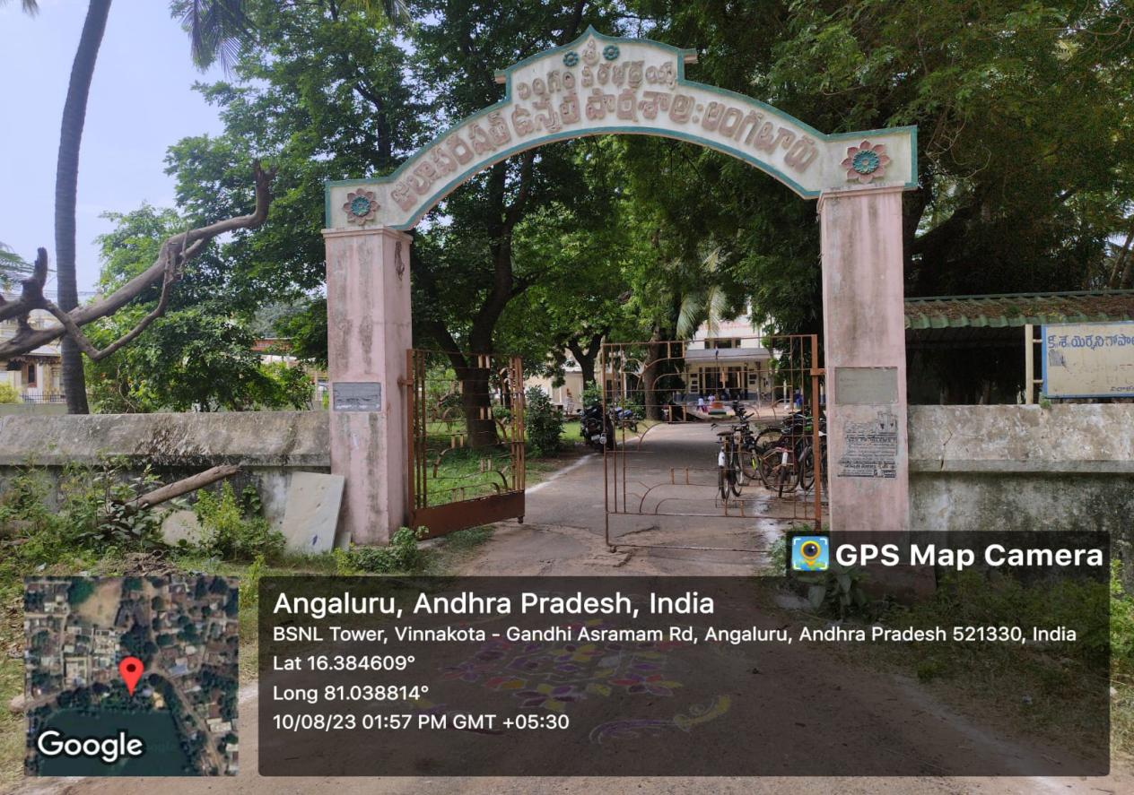

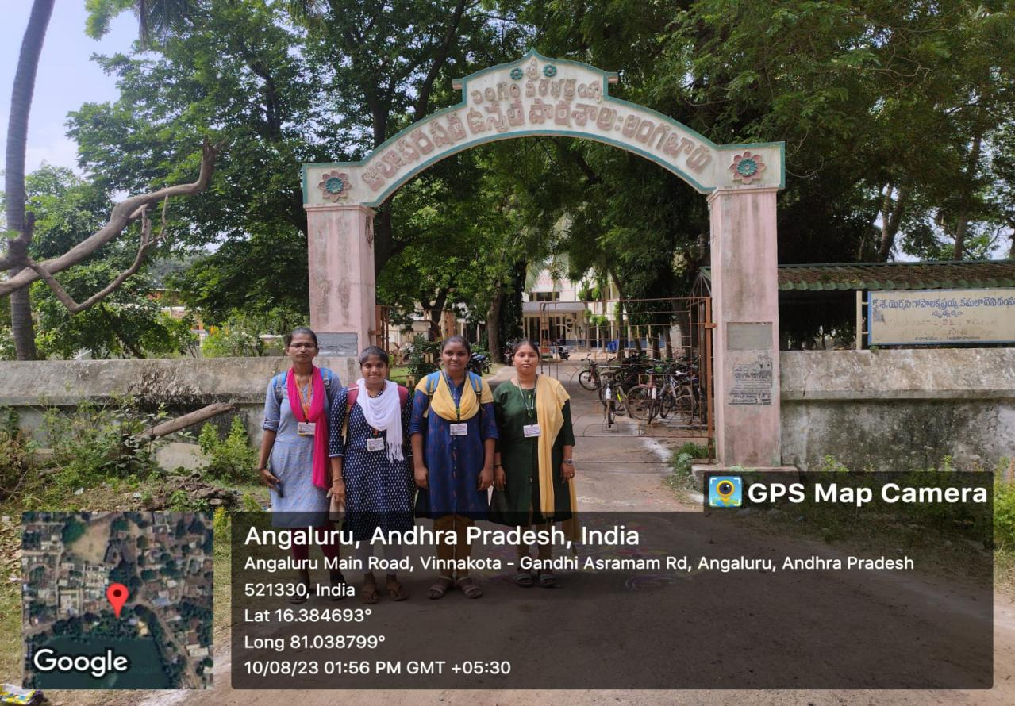

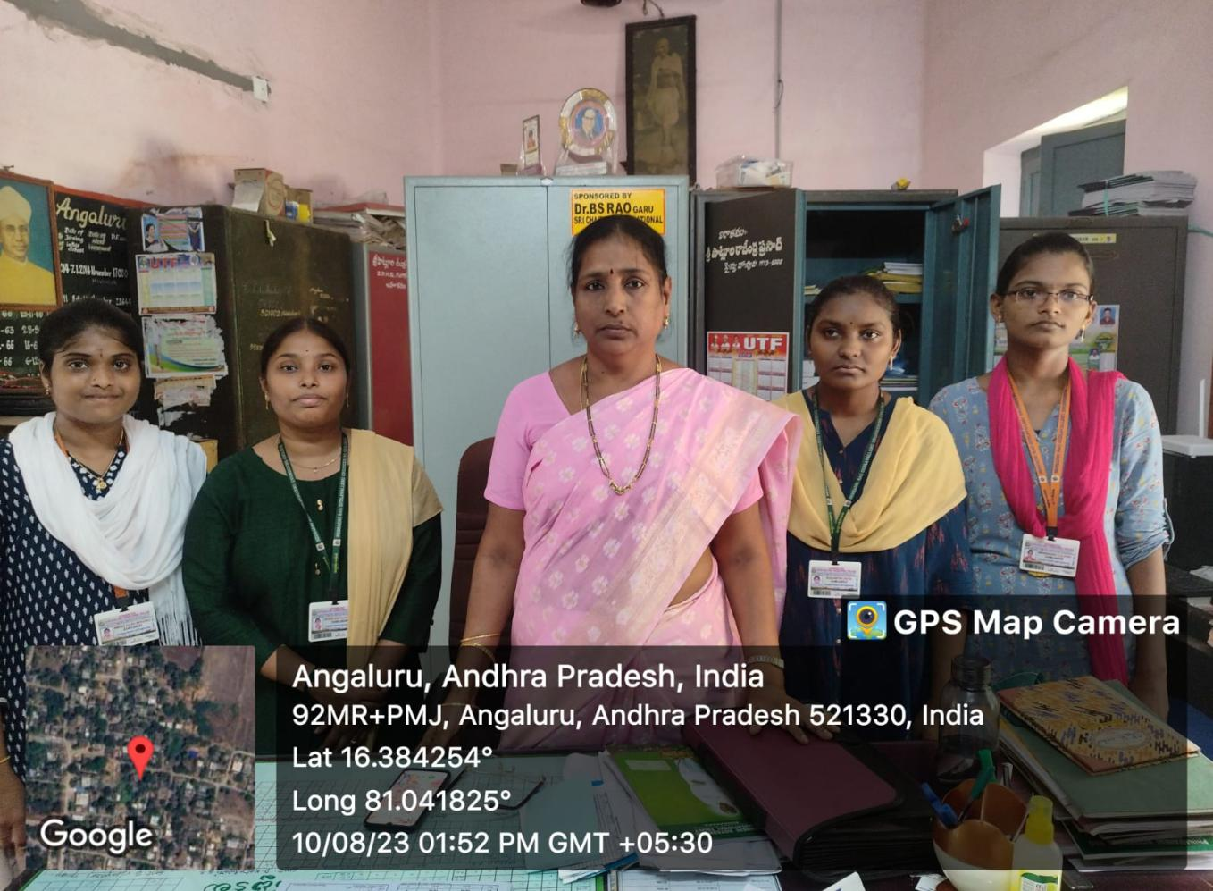

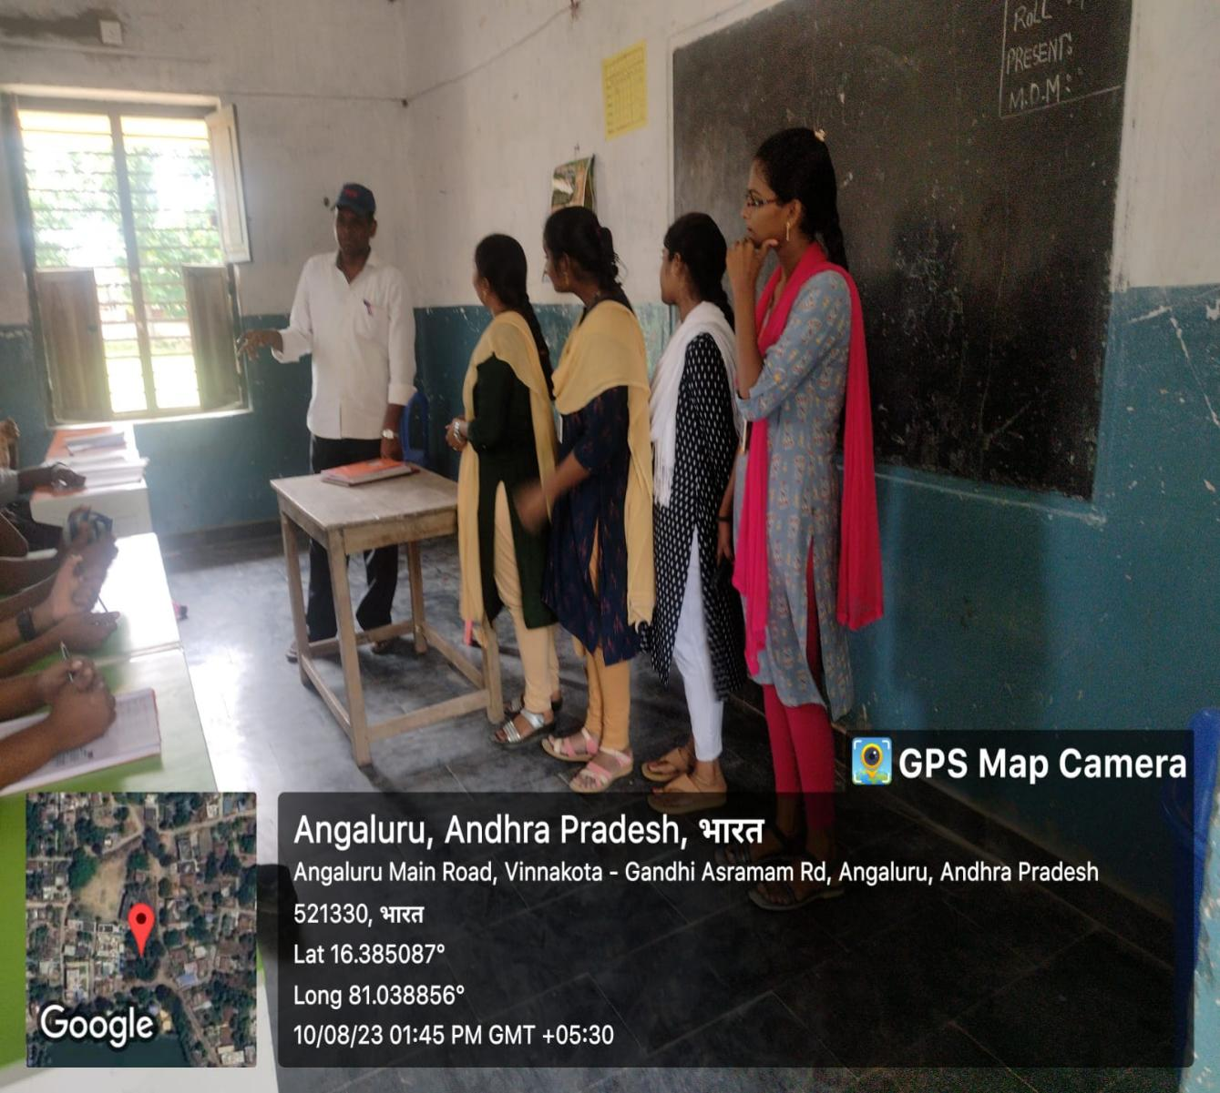

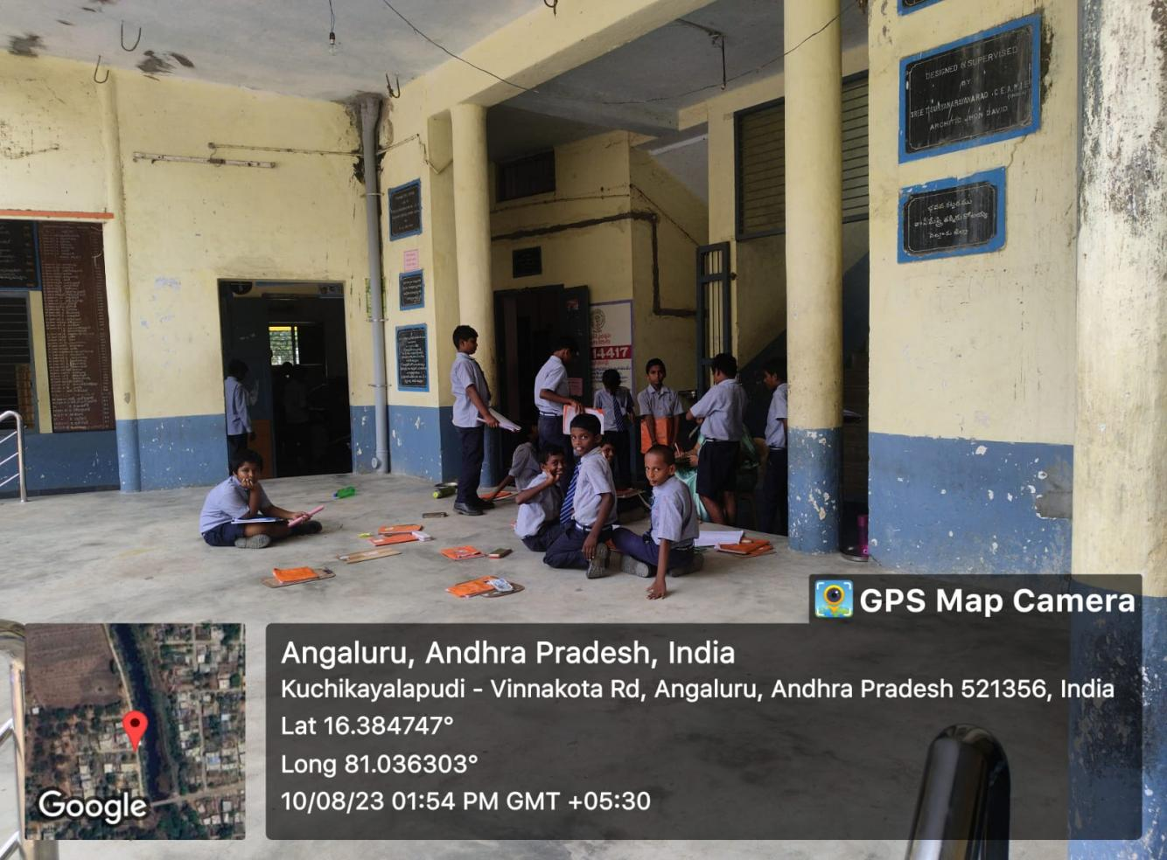

**LINKS:**

**<https://www.instagram.com/p/C1PIHXovpit1lUvM5NyfbXkulRmZEBLQ5-YNZs0/?igsh=emtyM3U5ODhzZTky>**

**SESHADRI RAO**

**GUDLAVALLERU ENGINEERING COLLEGE**

(An Autonomous Institute with Permanent Affiliation to JNTUK, Kakinada)

Seshadri Rao Knowledge Village, Gudlavalleru

**Department of Computer Science and Engineering**

Program Outcomes (POs) Engineering Graduates will be able to:

**1.Engineering knowledge**: Apply the knowledge of mathematics, science,

engineering fundamentals, and an engineering specialization to the solution of

complex engineering problems.

**2.Problem analysis:** Identify, formulate, review research literature, and analyze

complex engineering problems reaching substantiated conclusions using first

principles of mathematics, natural sciences, and engineering sciences.

**3.Design/development of solutions**: Design solutions for complex engineering

problems and design system components or processes that meet the specified needs

with appropriate consideration for the public health and safety, and the cultural,

societal, and environmental considerations.

**4.Conduct investigations of complex problems:** use research-based knowledge

and research methods including design of experiments, analysis and interpretation of

data, and synthesis of the information to provide valid conclusions., component, or

software to meet the desired needs.

**5. Modern tool usage**: Create, select, and apply appropriate techniques, resources,

and modern engineering and IT tools including prediction and modeling to complex

engineering activities with an understanding of the limitations.

**6. The engineer and society**: Apply reasoning informed by the contextual

knowledge to assess societal, health, safety, legal and cultural issues and the

consequent responsibilities relevant to the professional engineering practice.

7**. Environment and sustainability**: Understand the impact of the professional

engineering solutions in societal and environmental contexts, and demonstrate the

knowledge of, and need for sustainable development.

**8. Ethics:** Apply ethical principles and commit to professional ethics and

responsibilities and norms of the engineering practice

**9. Individual and team work:** Function effectively as an individual, and as a

member or leader in diverse teams, and in multidisciplinary settings.

**10.Communication:** Communicate effectively on complex engineering activities

with the engineering community and with society at large, such as, being able to

comprehend and write effective reports and design documentation, make effective

presentations, and give and receive clear instructions.

**11.Project management and finance**: Demonstrate knowledge and understanding

of the engineering and management principles and apply these to one’s own work, as

a member and leader in a team, to manage projects and in multidisciplinary

environments.

**12.Life-long learning**: Recognize the need for, and have the preparation and ability

to engage in independent and life-long learning in the broadest context of

technological change.

**Program Specific Outcomes (PSOs)**

PSO1 : Design, develop, test and maintain reliable software systems and intelligent

systems.

PSO2 : Design and develop web sites, web apps and mobile apps.

**PROJECT PROFORMA**

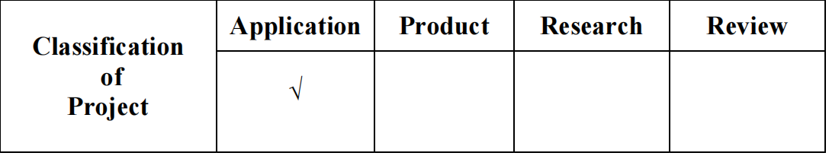

**Note: Tick Appropriate category.**

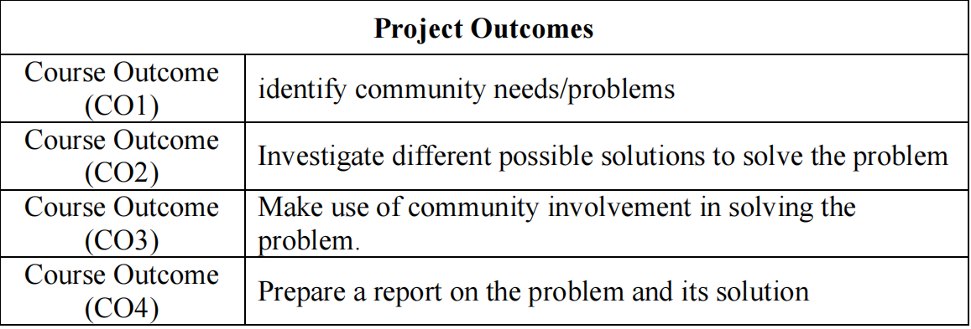

**Mapping Table**

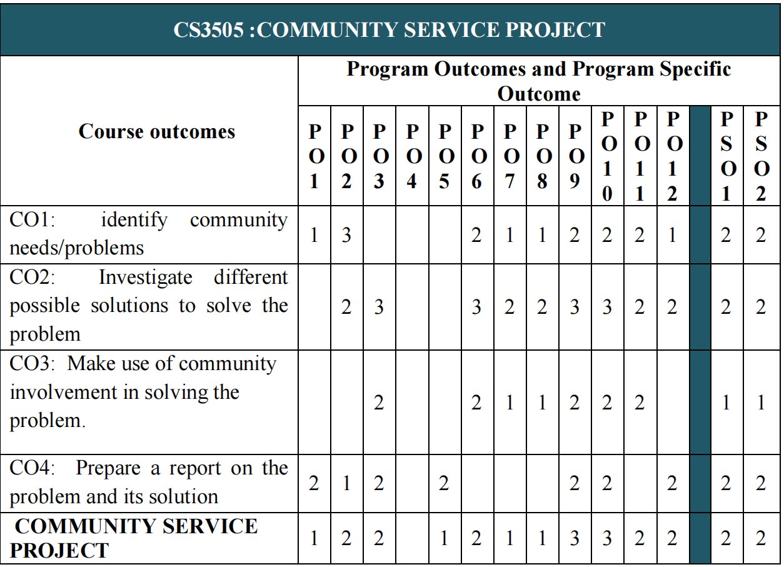

**Note: Map each project outcomes with POs and PSOs with either 1 or 2 or 3**

**based on level of mapping as follows:**

1-Slightly(Low)mapped 2-Moderately (Medium) mapped 3-Substantially(High) mapped